Professional Logo Design
English (American)

Sales Slick · v2.1 · Page 1 of 3

Build a brand customers recognize, trust, and remember.

Credibility

Recognition

Versatility

Ownership

PROFESSIONAL LOGO DESIGN

WHY A PROFESSIONAL LOGO MATTERS

FOUR REASONS TO INVEST

SELECTED WORK
Custom, human-designed logos built around your business — delivered in 11 file formats, fully owned by you, ready for every application from your website to your vehicle wrap.
To form a first impression.
Identify a logo as the #1 brand symbol.
Recognition lift from a strong logo.
Look established the moment a customer sees you.
Stand out from competitors and stay memorable.
11 formats — ready for web, print, signage, social.
You own your logo outright. Trademark it.
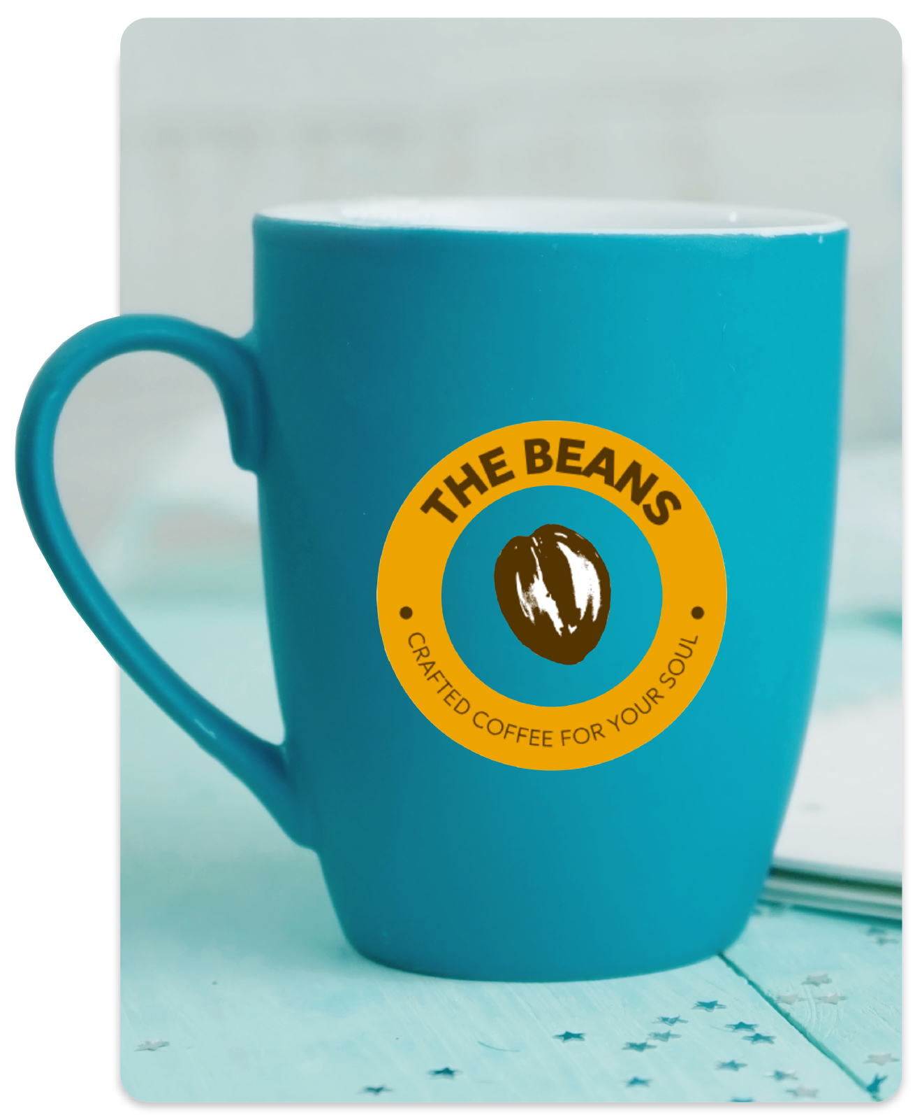

Sales Slick · v2.1 · Page 2 of 3

From brief to final files in two to three weeks.

Creative brief

Custom concepts

Final delivery

Three tiers for every budget.

HOW IT WORKS

PLANS
A dedicated coordinator manages every step. No template farms. No designer roulette. Just a clear, three-stage process built for small businesses.
A dedicated Logo Design Coordinator contacts the customer within two business days to capture the creative brief — business goals, style preferences, colors, and reference logos.
In-house designers deliver up to ten original concepts in three to five business days. Up to three rounds of revisions are included to get the final design exactly right.
Final files arrive within three business days of concept approval — 11 formats (AI, EPS, PDF, JPG, PNG, GIF, ICO), full rights transferred, ready for any application.
All plans include the Logo Design Coordinator, three rounds of revisions, the 11-format file package, and full ownership of the design.
- Logo Design Coordinator
- 4 custom design concepts
- 3 rounds of revisions
- 11 final file formats
- Full ownership of design
- Everything in Bronze
- 6 custom design concepts
- Business card design
- Letterhead & envelope
- Everything in Silver
- 10 custom design concepts
- 1,000 printed business cards
- Branded email signature

Sales Playbook · v2.1 · Page 3 of 3

How to sell Professional Logo Design.

SALES PLAYBOOK
Rep-facing reference. Ideal customer profile, discovery questions, objection handling — all on one page.
New SMBs establishing a brand for the first time
Established businesses with logos older than 7–10 years
Trust-heavy verticals: contractors, plumbers, restaurants, legal, healthcare
Ecommerce SMBs needing a logo for packaging, print, and digital
Any SMB using a free logo tool (they don't own their design)
Walk me through how customers first discover your business.
When did you last update your logo? Average rebrand: 7–10 years.
Does your logo match your signage, cards, and social presence?
What do you want customers to feel when they see your brand?
Ever had a customer confuse you with a competitor?
Any print plans coming up — vehicle wraps, uniforms, packaging?
If starting fresh, would you want a trademark-able logo you fully own?
Plans start at entry-level pricing. Logos last 7–10 years — pennies a day for your strongest brand asset.
They do — new ones don't. 75% of consumers identify brands by their logo. Referrals need something visual.
Free tools often don't transfer full rights, so you can't trademark — and a similar business could end up with the same design.
How old is it? 7–10 year lifespan. The coordinator can recommend refresh vs. redesign.
Design experience? Full rights? Vector formats for signage? Most favors miss these.
Human-designed, full rights, 11 formats.
Dedicated coordinator, 75K+ logos delivered in-house.
Human logos are more differentiated and easier to trademark.

